Create a Cloning of a VM and Test it by loading the Previous Version/Cloned VM.

Procedure:

Step1: Creating a Clone Virtual Machine.

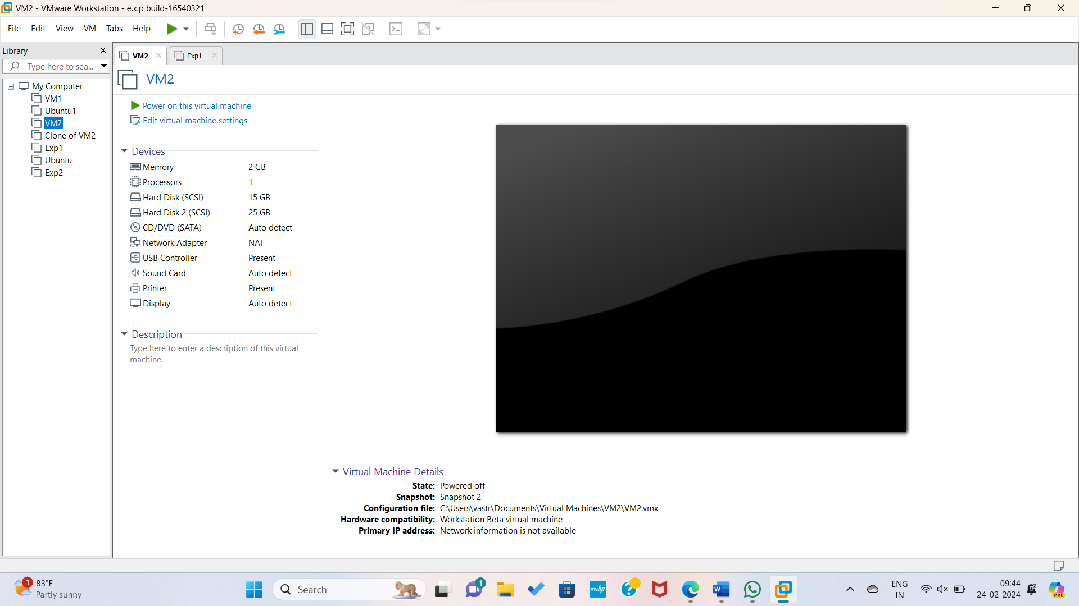

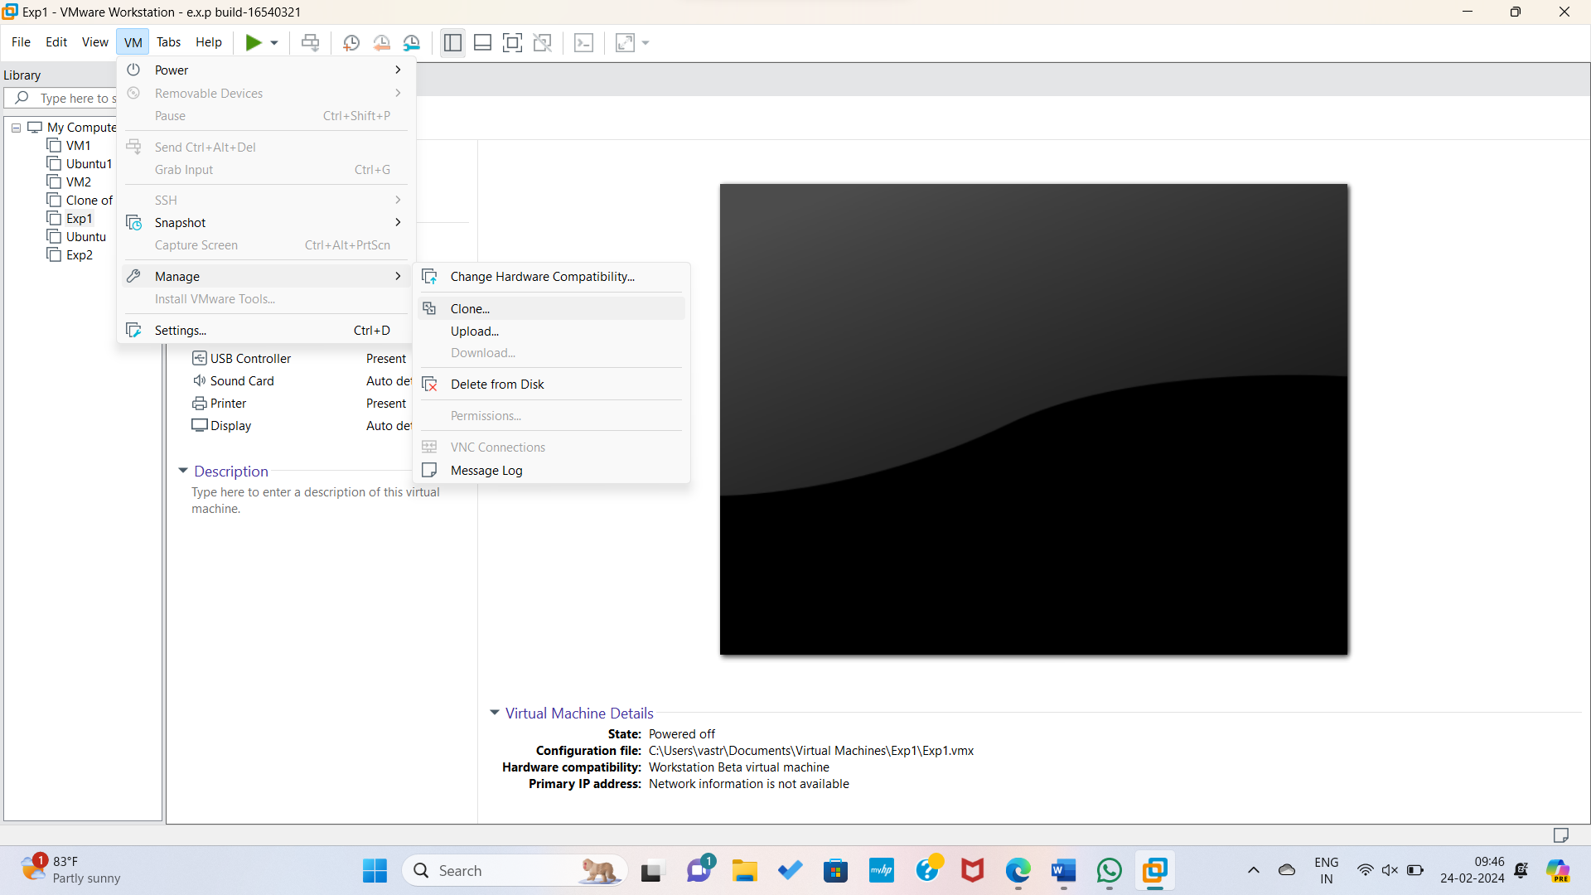

Step2: Creating a clone of VM in VM Application.

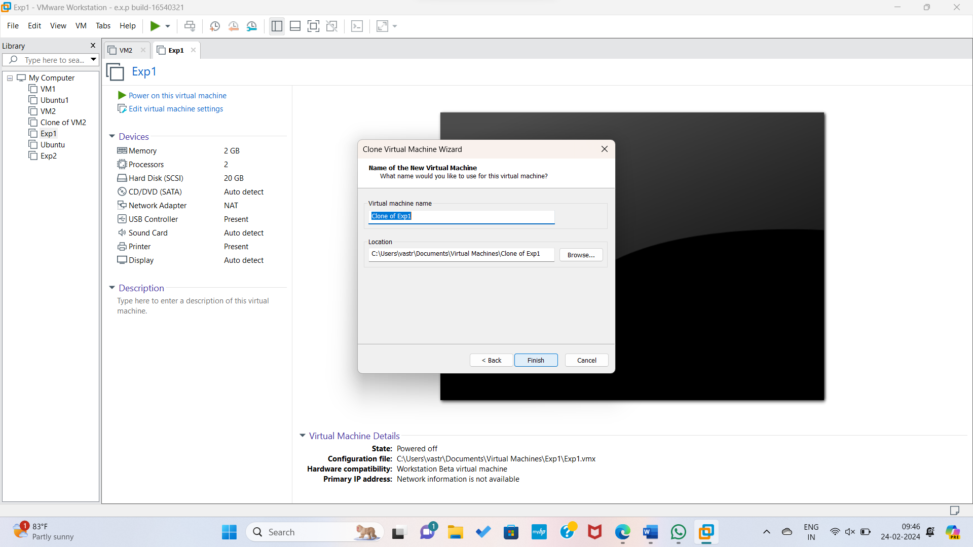

Step3: Clone of the Virtual Machine Created Successfully.

